Objectives
- To examine and compare the mandatory financial disclosure requirements applicable to Indian listed companies, with reference to DMart and Trent Ltd.
- To analyse and compare voluntary investor communication practices adopted by DMart and Trent Ltd beyond mandatory disclosure requirements.
- To evaluate the extent and nature of voluntary disclosures made by the selected companies and identify differences in their investor communication approaches
- To assess the role of voluntary investor communication in enhancing transparency over and above mandatory financial filings.

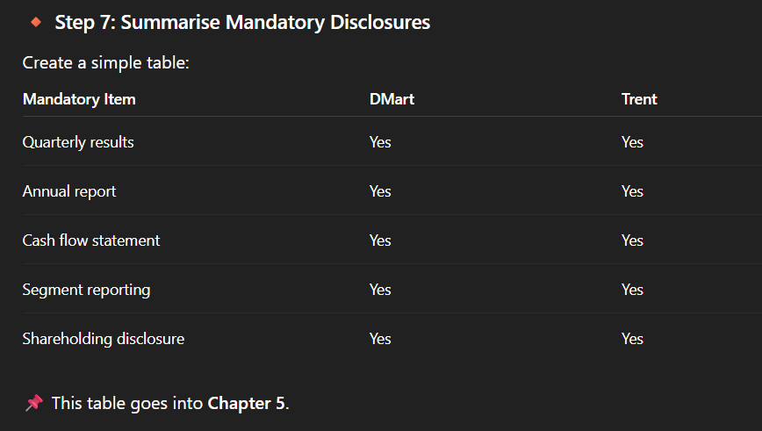

Environmental, Social, and Governance (ESG) Metrics
Employee Welfare and Diversity Data
conference calls and investor presentations

TABLE OF CONTENTS
Concall transcript
Investor presentations
Interviews
Future guidance

ABSTRACT

CHAPTER 1: INTRODUCTION

